**A&S CHIT FUNDS**

* **#we.grow.together**

*Mini Project Report*

*Submitted in partial fulfilment of the*

*Requirements for the award of the Degree of*

**BACHELOR OF ENGINEERING**

IN

**INFORMATION TECHNOLOGY**

By

**KOYALKAR SAI PRASAD– 1602-19-737-095**

**AKASH REDDY– 1602-19-737-063**



**Department of Information Technology**

**Vasavi College of Engineering (Autonomous)**

**(Affiliated to Osmania University)**

**Ibrahimbagh, Hyderabad-31**

**2020**

**Vasavi College of Engineering (Autonomous)**

**(Affiliated to Osmania University)**

**Hyderabad-500 031**

**Department of Information Technology**



We KOYALKAR SAI PRASAD and AKASH REDDY bearing hall ticket numbers, 1602-19-737-095 and 1602-19-737-063 respectively, hereby declare that the project report entitled “A&S CHIT FUNDS ” is submitted in partial fulfilment of the requirement for the award of the degree of Bachelor of Engineering in Information Technology.

This is a record of bonafide work carried out by us and the results embodied in this project report have not been submitted to any other university or institute for the award of any other degree or diploma.

**KOYALKAR SAI PRASAD – 1602-19-737-095**

**AKASH REDDY – 1602-19-737-063**

(Faculty In-Charge) (Head,Dept of IT)

ACKNOWLEDGEMENTS

The satisfaction that accompanies the successful completion of this project would not be in complete without the mention of the people who made it possible, without whose constant guidance and encouragement would have made efforts go in vain. We consider ourselves privileged to express gratitude and respect towards all those who guided us through the completion of this project.

We thank our faculty (Prasanna mam) because they clarified our few doubts regarding to the project, gave few suggestions and guided us by which we successfully completed our project.

Last but not the least, we wish to thank our parents for financing our studies in this privileged Vasavi College of Engineering as well as for constantly encouraging us to learn engineering. Their personal sacrifice in providing this opportunity to learn engineering is gratefully acknowledged.

ABSTRACT

We  creat a chit fund software ,which is a ​integrated solution to lead your chit fund business ​from our application. A user can creat an account and can make chits or join in chits that are exist ,add members to chits, and view friends complete details, and their joined chits,and payment status all from one application. It can help you exactly cut time on planning reports.

**Table of contents**

|  |  |
| --- | --- |
| **Topic** | **Page Number** |
| **Introduction** | 6 |
| **Technology** | 7 |
| **Proposed Work** | 8 - 14 |
| **Results** | 15-23 |
| **Additional Knowledge Acquired** | 24 |
| **Conclusions and Future work** | 25 |
| **References** | 26 |

INTRODUCTION

ABOUT THE PROJECT

“A&S CHIT FUNDS” is a console-based C Project which is a ​integrated solution to lead your chit fund business ​from our application.. The program is run by the user or customer who can create, join, modify, and pay the chits according to the need. And he can see his chit members complete info.

OBJECTIVE OF OUR PROJECT

The Main aim of developing this project is to provide any easy way to automate all functionalities involved in managing chits. Nowadays large scale organization are committed to bring the best way of management in the various forms .

TECHNOLOGY

All computer software needs certain hardware components or other software resources to be present, in order for computers to be used efficiently. These prerequisites are known as System Requirements. Within this, we have two types – Software Requirements and Hardware Requirements.

## SOFTWARE REQUIREMENTS

Software Requirements deal with defining the software resource requirements and prerequisites that need to be installed on a computer to provide optimal functioning of an application. These preconditions are generally not included in the software installation package and need to be installed separately.

In order to use CODIAC, one should have the following:

* **Operating System:** Windows 7 and above
* **C Compiler:** GNU Compiler Collection (GCC)
* **Editor:** VS CODE

## HARDWARE REQUIREMENTS

Hardware requirements refer to the common set requirements defined by any operating system or software application and are usually the physical computer resources. In this, we look into the architecture, processing power, memory, secondary memory, display adapter and peripherals.

In order to use this project, one should have the following:

* + - **Processor:** Intel Pentium processor and above
    - **Memory:** 4 GB RAM and above

**Proposed work**

**DESIGN**

Our approach in designing CHIT FUND SOFTWARE APPLICATION to reduce the pen and paper work to manage the records in any organization (educational institutions).

**USE CASES**

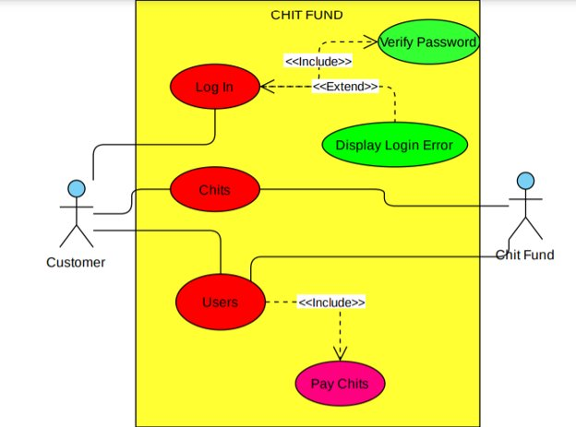

**FLOW CHART:**

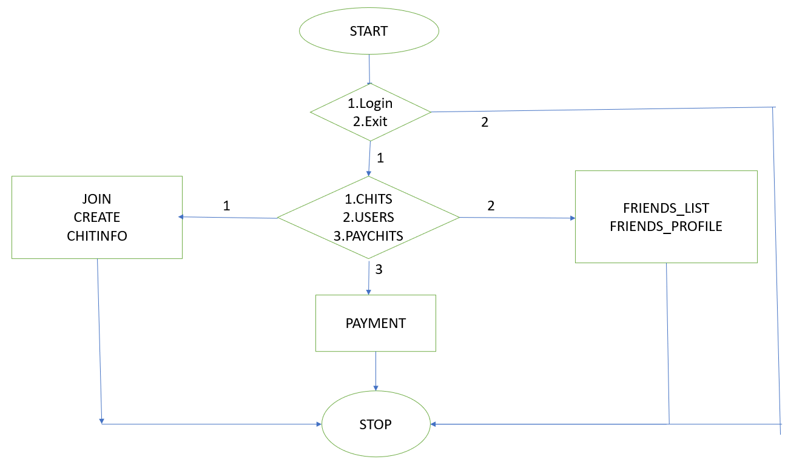

**Implementation**

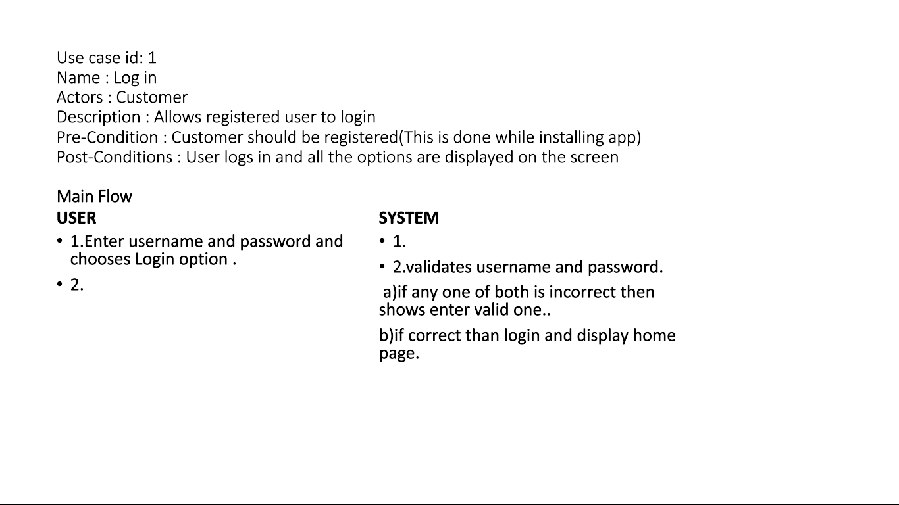

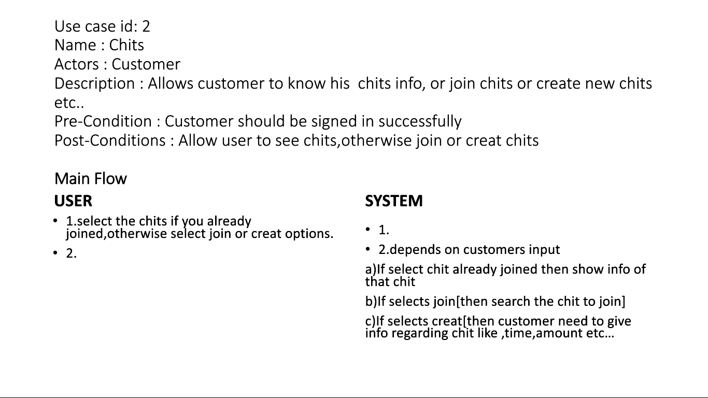

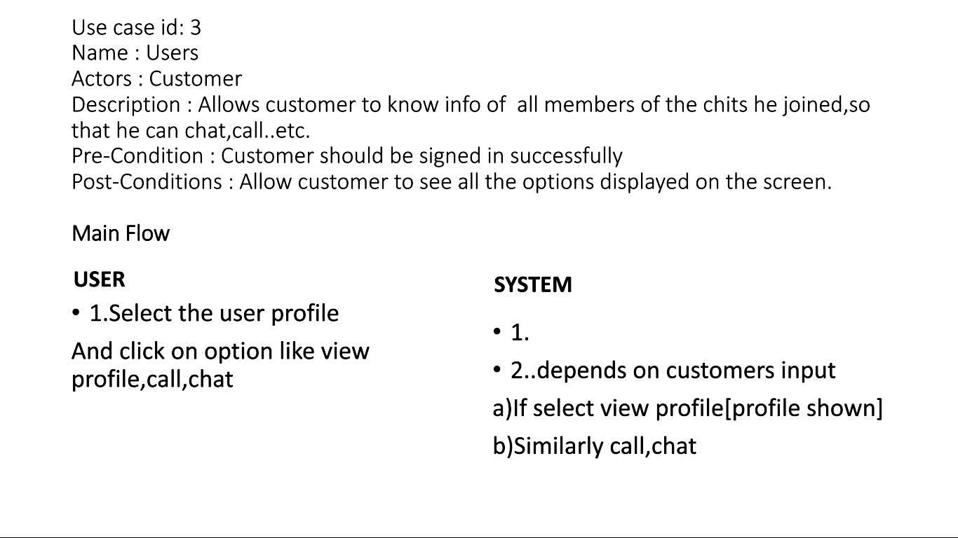

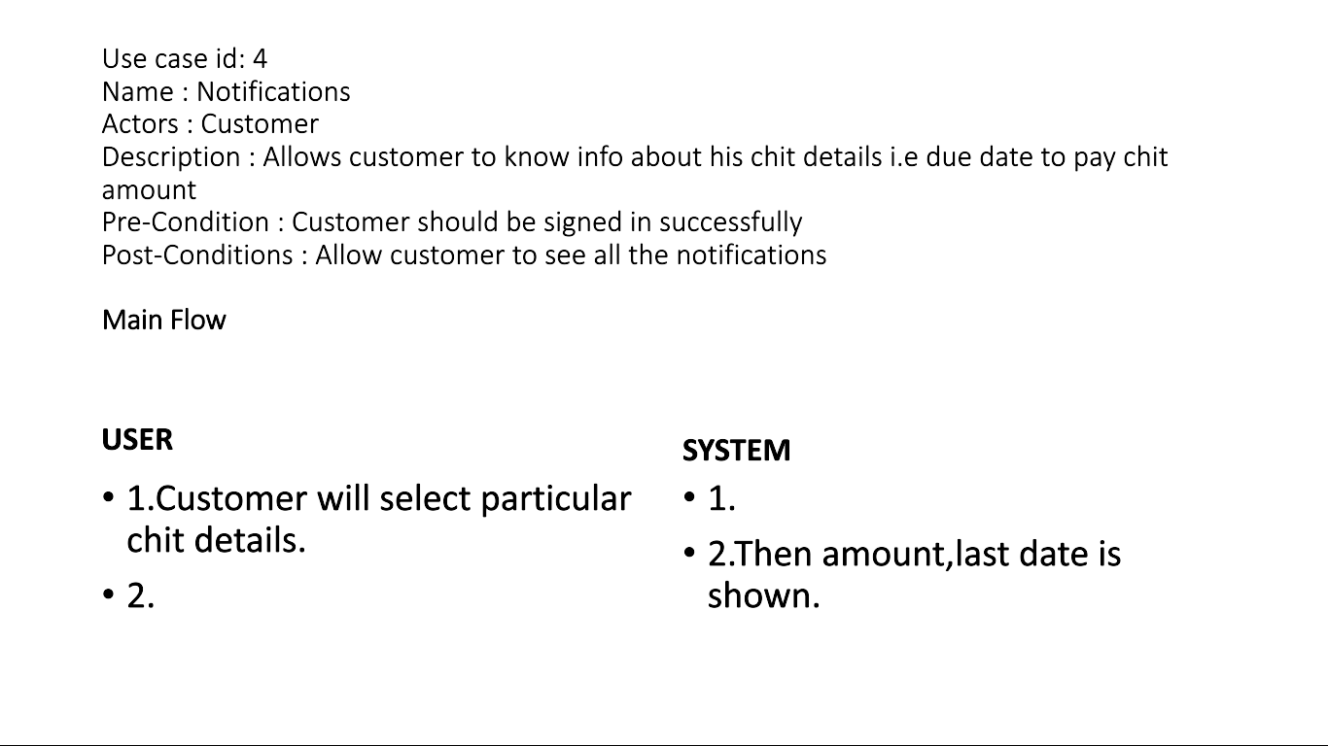

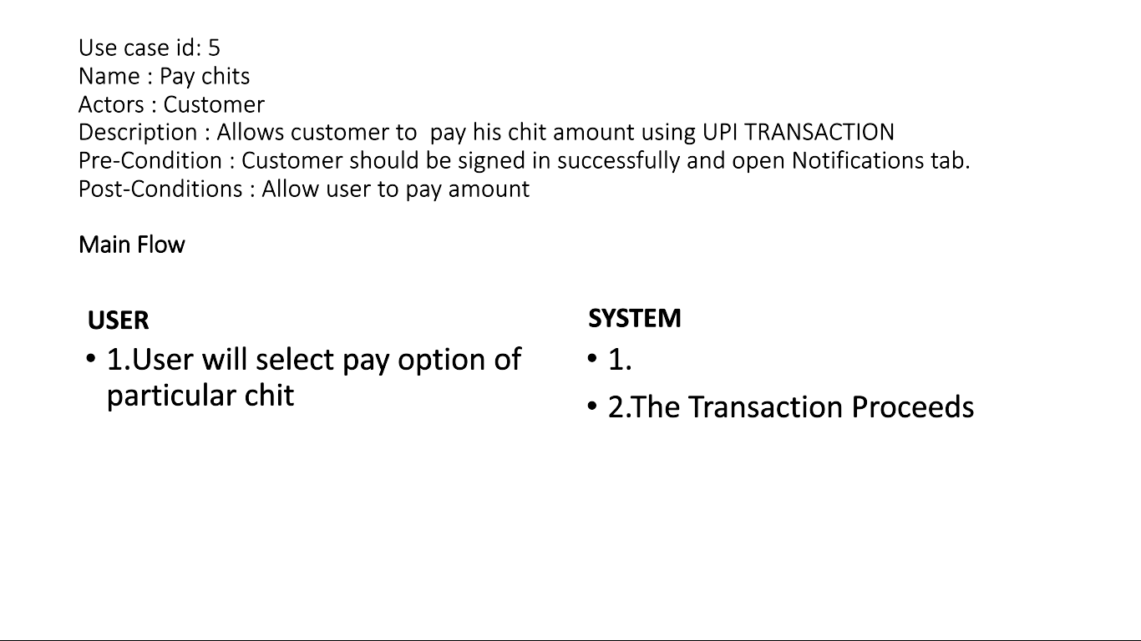

1. Github links and folder structure.

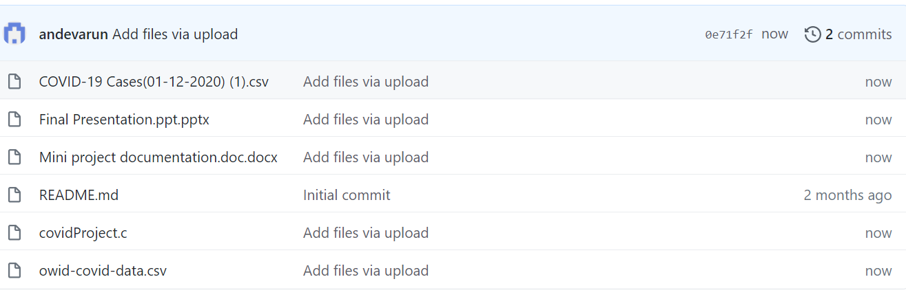

**4.RESULTS**

LOGIN

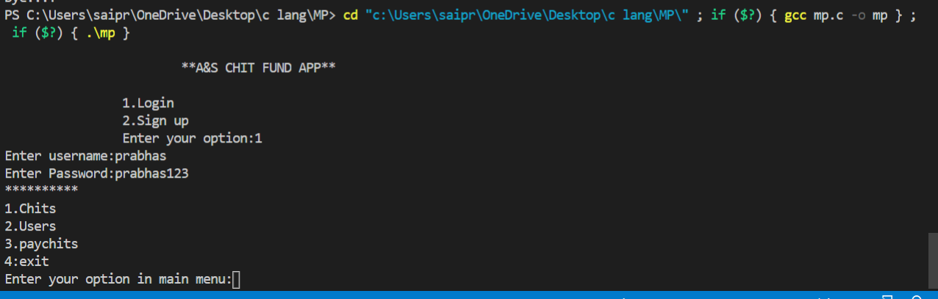

CREATE CHITS (CHITS)

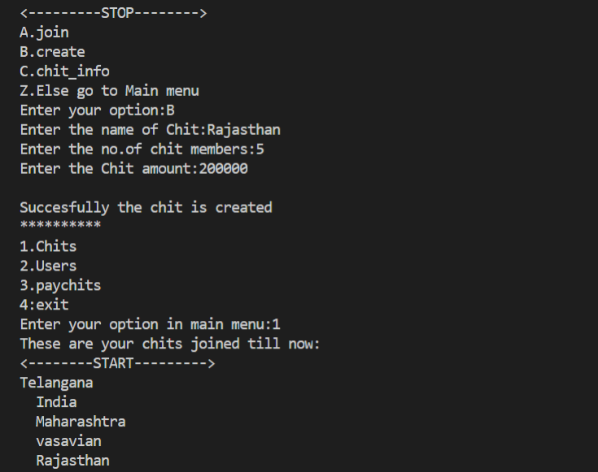

JOIN RECORDS

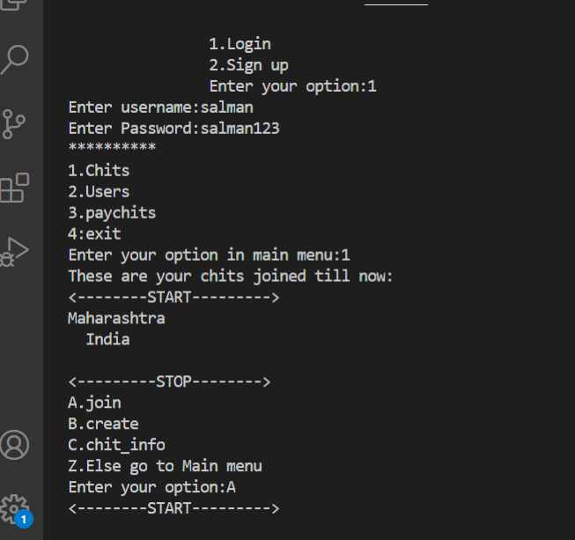

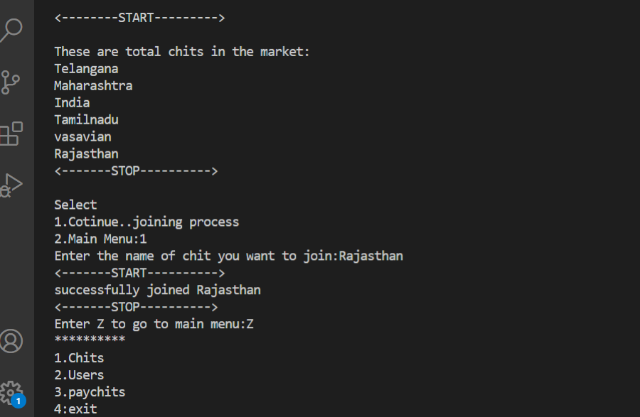

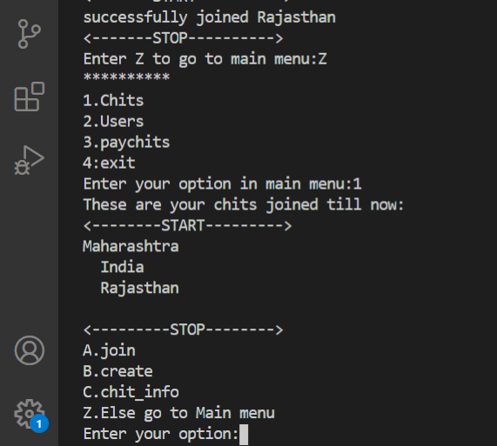

CHIT INFO

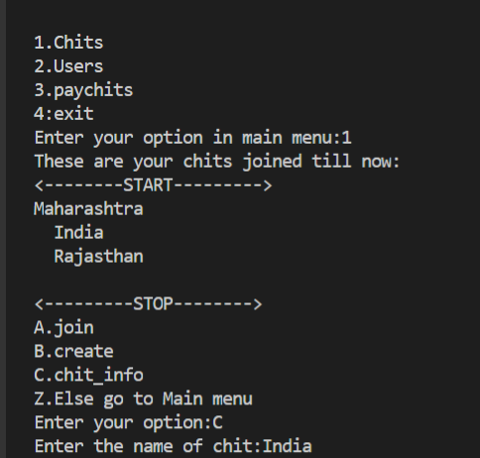

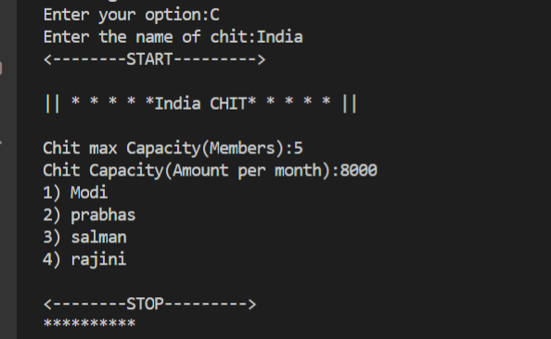

FRIENDS LIST

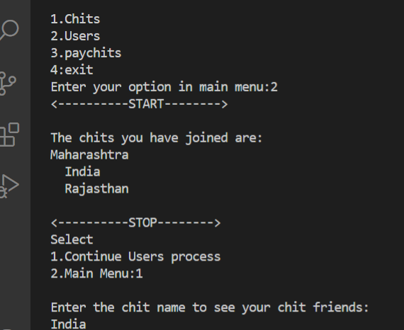

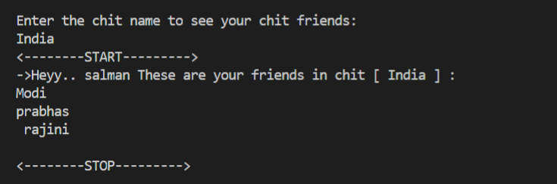

FRIENDS PROFILE

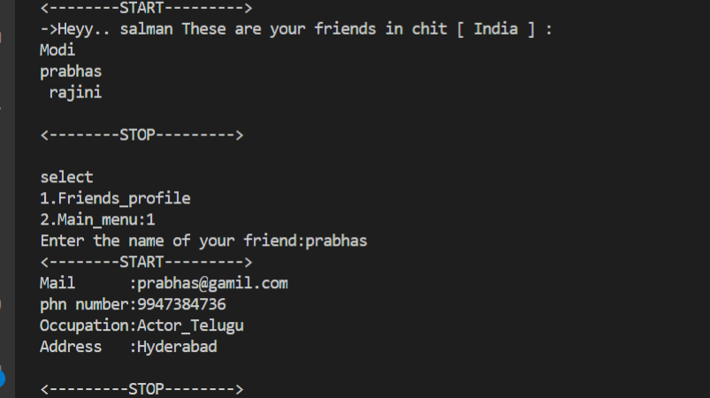

PAYCHITS

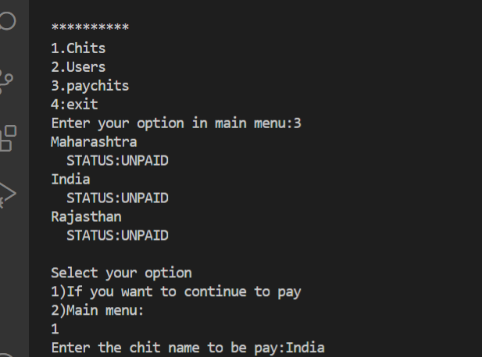

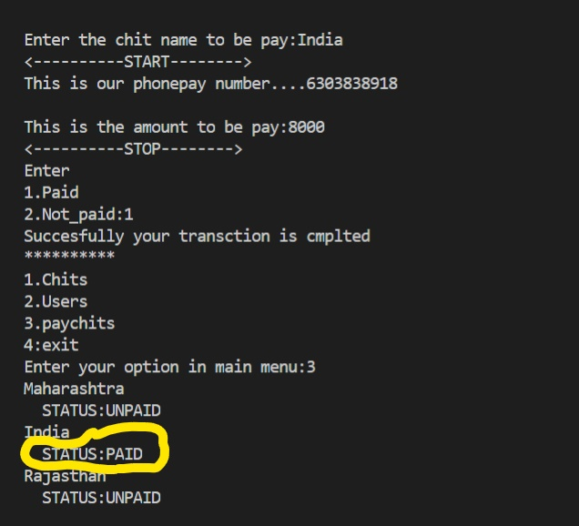

EXIT

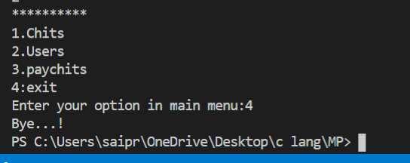

**What was the additional learning apart from the course programming for problem solving relate the ideas that you have gained implementing this mini project?**

we have further improved in our knowledge in file-handling because of the vast amount of data manipulation we have done using text files.

Other than this, we have learnt the value of team spirit and have understood the intention behind working in teams. We have learnt to be team players.

**6 .CONCLUSION AND FUTURE WORK**

To conclude, this application is useful not only for educational institution but

Also for any other organization who are keen to utilize this kind of application. It can be operated very easily.

Future work is to we develop the application in PHP Or HTML to make the real payment, make this console application as a web application.

**7. REFERENCES**

1. C Language Documentation: [https://docs.microsoft.com/en-us/cpp/c- language/?view=msvc-160](https://docs.microsoft.com/en-us/cpp/c-language/?view=msvc-160)
2. Visual Studio Code:
3. Stack Overflow (for debugging errors): <https://stackoverflow.com/> 4.